SCHOOL

Trial WACE Examination, 2010

Question/Answer Booklet

MATHEMATICS:
SOLUTIONS

SPECIALIST

3C/3D

Section One:

Calculator-free

Student Number: In figures

In words

Your name

Time allowed for this section
Reading time before commencing work: 5 minutes
Working time for paper: 50 minutes

Material required/recommended for this section

To be provided by the supervisor
This Question/Answer booklet
Formula sheet

To be provided by the candidate
Standard items: pens, pencils, pencil sharpener, eraser, correction fluid, ruler, highlighters

Special items: nil

Important note to candidates

No other items may be used in this section of the examination. It is your responsibility to ensure that you do not have any unauthorised notes or other items of a non-personal nature in the examination room. If you have any unauthorised material with you, hand it to the supervisor before reading any further.

Structure of this paper

Section | Number of questions available | Number of questions to be answered | Working time (minutes) | Marks available
Section One:  Calculator-free | 7 | 7 | 50 | 40
Section Two:  Calculator-assumed | 11 | 11 | 100 | 80
 |  |  |  | 120

Instructions to candidates

- The rules for the conduct of Western Australian external examinations are detailed in the Year 12 Information Handbook 2010. Sitting this examination implies that you agree to abide by these rules.

- Write your answers in the spaces provided in this Question/Answer Booklet. Spare pages are included at the end of this booklet. They can be used for planning your responses and/or as additional space if required to continue an answer.
- Planning: If you use the spare pages for planning, indicate this clearly at the top of the page.
- Continuing an answer: If you need to use the space to continue an answer, indicate in the original answer space where the answer is continued, i.e. give the page number. Fill in the number of the question(s) that you are continuing to answer at the top of the page.

- Show all your working clearly. Your working should be in sufficient detail to allow your answers to be checked readily and for marks to be awarded for reasoning. Incorrect answers given without supporting reasoning cannot be allocated any marks. For any question or part question worth more than two marks, valid working or justification is required to receive full marks. If you repeat an answer to any question, ensure that you cancel the answer you do not wish to have marked.

- It is recommended that you do not use pencil except in diagrams.

Section One: Calculator-free (40 Marks)
This section has seven (7) questions. Answer all questions. Write your answers in the space provided.

Working time for this section is 50 minutes.

Question 1 (4 marks)
The graph of 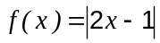 is shown below.
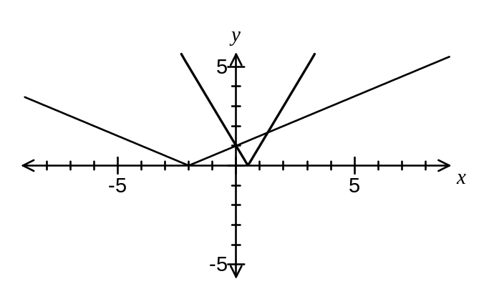
(a) Add the function 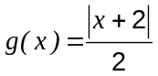 to the graph. (1 mark)

(b) Solve 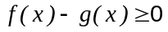. (3 marks)
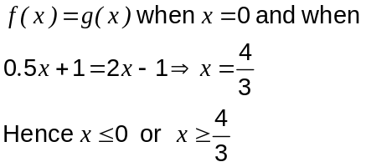

Question 2 (7 marks)
Two complex numbers are given by 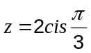 and 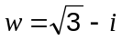.
(a) Determine 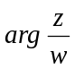 (2 marks)
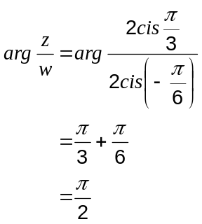

(b) Evaluate 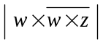. (3 marks)
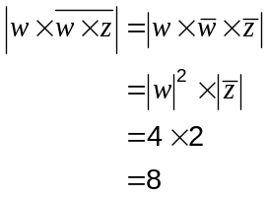

(c) Find the complex number given that 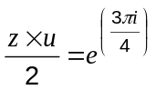. (2 marks)
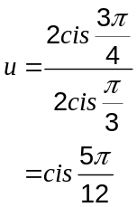

Question 3 (4 marks)
The sound level, in decibels (dB), for a single sound of pressure, in millipascals (mPa), is calculated using the formula 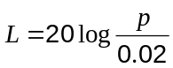, 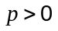.

(a) Determine the sound level corresponding to a sound pressure of 0.02 mPa. (1 mark)
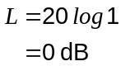

(b) Determine the sound pressure corresponding to a sound level of 80 dB. (1 mark)
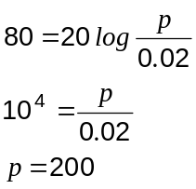

(c) Sketch the graph of the above function on the axes below with 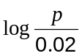 on the horizontal axis. Indicate the scale used on the vertical axis. (2 marks)

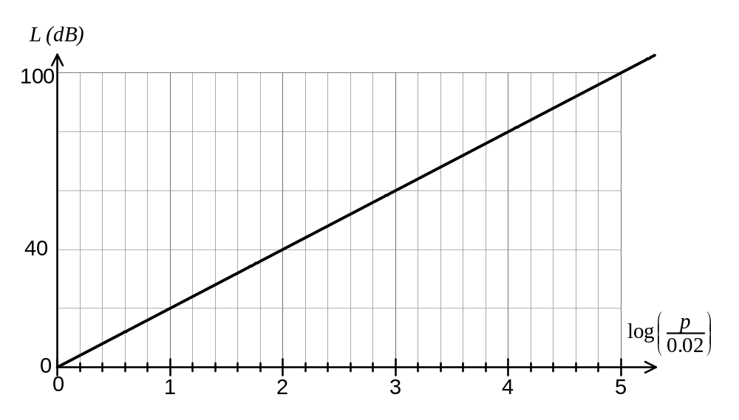

Question 4 (6 marks)
(a) Prove by deduction that 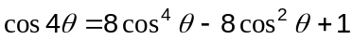.

You may assume all identities given on the standard formula sheet. (3 marks)

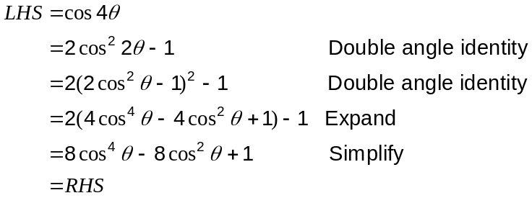

(b) Hence evaluate 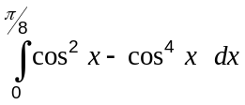. (3 marks)

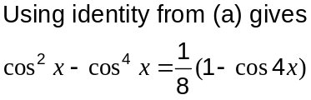

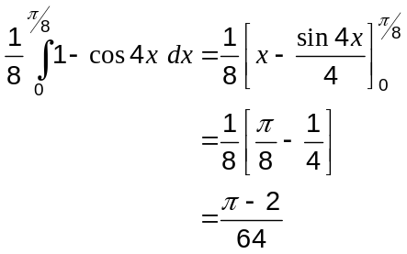

Question 5 (6 marks)
(a) Find the exact gradient of the curve 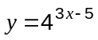 at the point (2, 4). (3 marks)
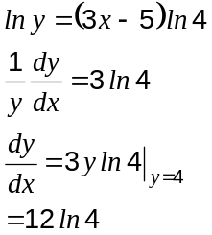

(b) Evaluate 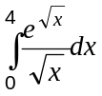. (3 marks)
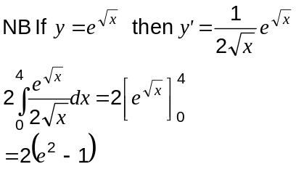

Question 6 (6 marks)
The graphs of 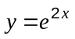 and 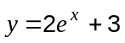 intersect at the point A, shown on the graph below.
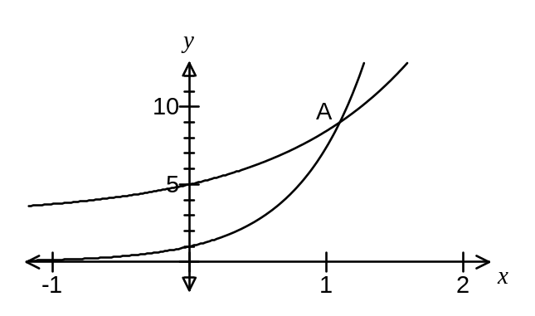
(a) Show that the -coordinate of A is 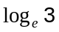. (3 marks)
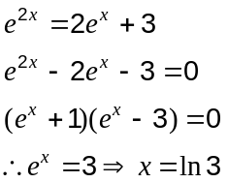

(b) Determine the exact area, in simplest form, of the region bounded by the two curves and the y-axis. (3 marks)
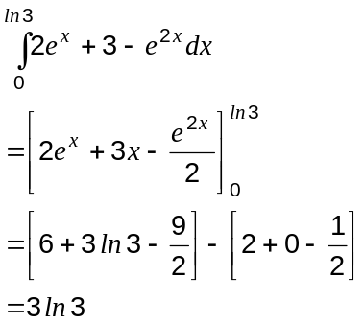

Question 7 (7 marks)
(a) If 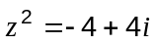 find

(i) 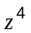 (1 mark)
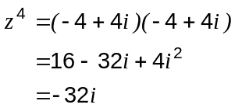

(ii) (3 marks)
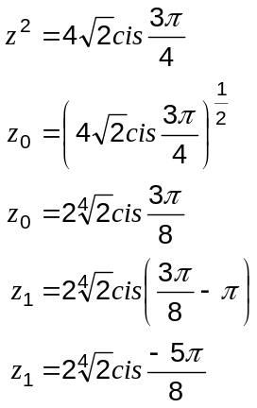

(b) Find real numbers and such that 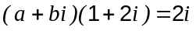. (3 marks)
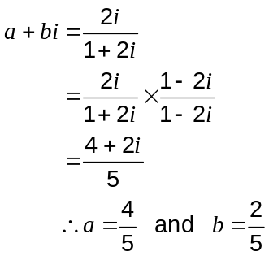

Additional working space

Question number(s):

Additional working space

Question number(s):

